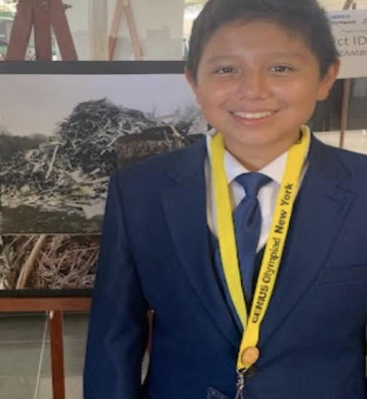
Name: Tonio Merchan
Year in Course: 1st (Sophomore)
Topic: Wolf and Dog Cognition, Learning and Socialization​
Mentor: N/A
Title: Investigating the Relationship between Wolf and Dog Cognition, Learning and Socialization​
Bio:
Tonio Merchan is a sophomore at Pawling high school, where he takes advanced classes and loves to learn new things. He is a very hard working dedicated student who does many extra activities which include clubs like yearbook and peer leadership which he enjoys doing because he is a very big-hearted student and he loves to help out the community. He joined peer leadership in his freshman year and has been participating in it for two continuous years. While taking these classes Tonio has become very in love and passionate about his subject. Another thing he enjoys doing is that he loves to play soccer for the school and his travel team. He has been in love with soccer his entire life and started ever since he was a boy. Tonio also helps out in community service events like the health and wellness event which he spent six hours of the day to make sure that children have the time of their life while playing around in the stations. When Tonio is not doing any of these things he is either playing other sports with his friends or hanging out with his cousins.
Tonio’s passion for wolves grew ever since he was a little boy because of his love for animals and because of his very own animals. As a little boy, Tonio loved dogs but his sister was allergic so he has always wanted to be able to study dogs and what they are capable of compared to their ancestor the wolves. Therefore Tonio was in love with the magnificent creatures and how they processed everything. As a result, he decided he wanted to pursue his passion for studying these magnificent creatures in the school’s very own science research department. Additionally, after joining science research Tonio is now in the process of studying the wolves and dogs and how their cognition, learning and socialization constructs impact behavior.

Awards/Achievements/Competitions

- Genius Olympiad Bronze Medal in Photography 2019

