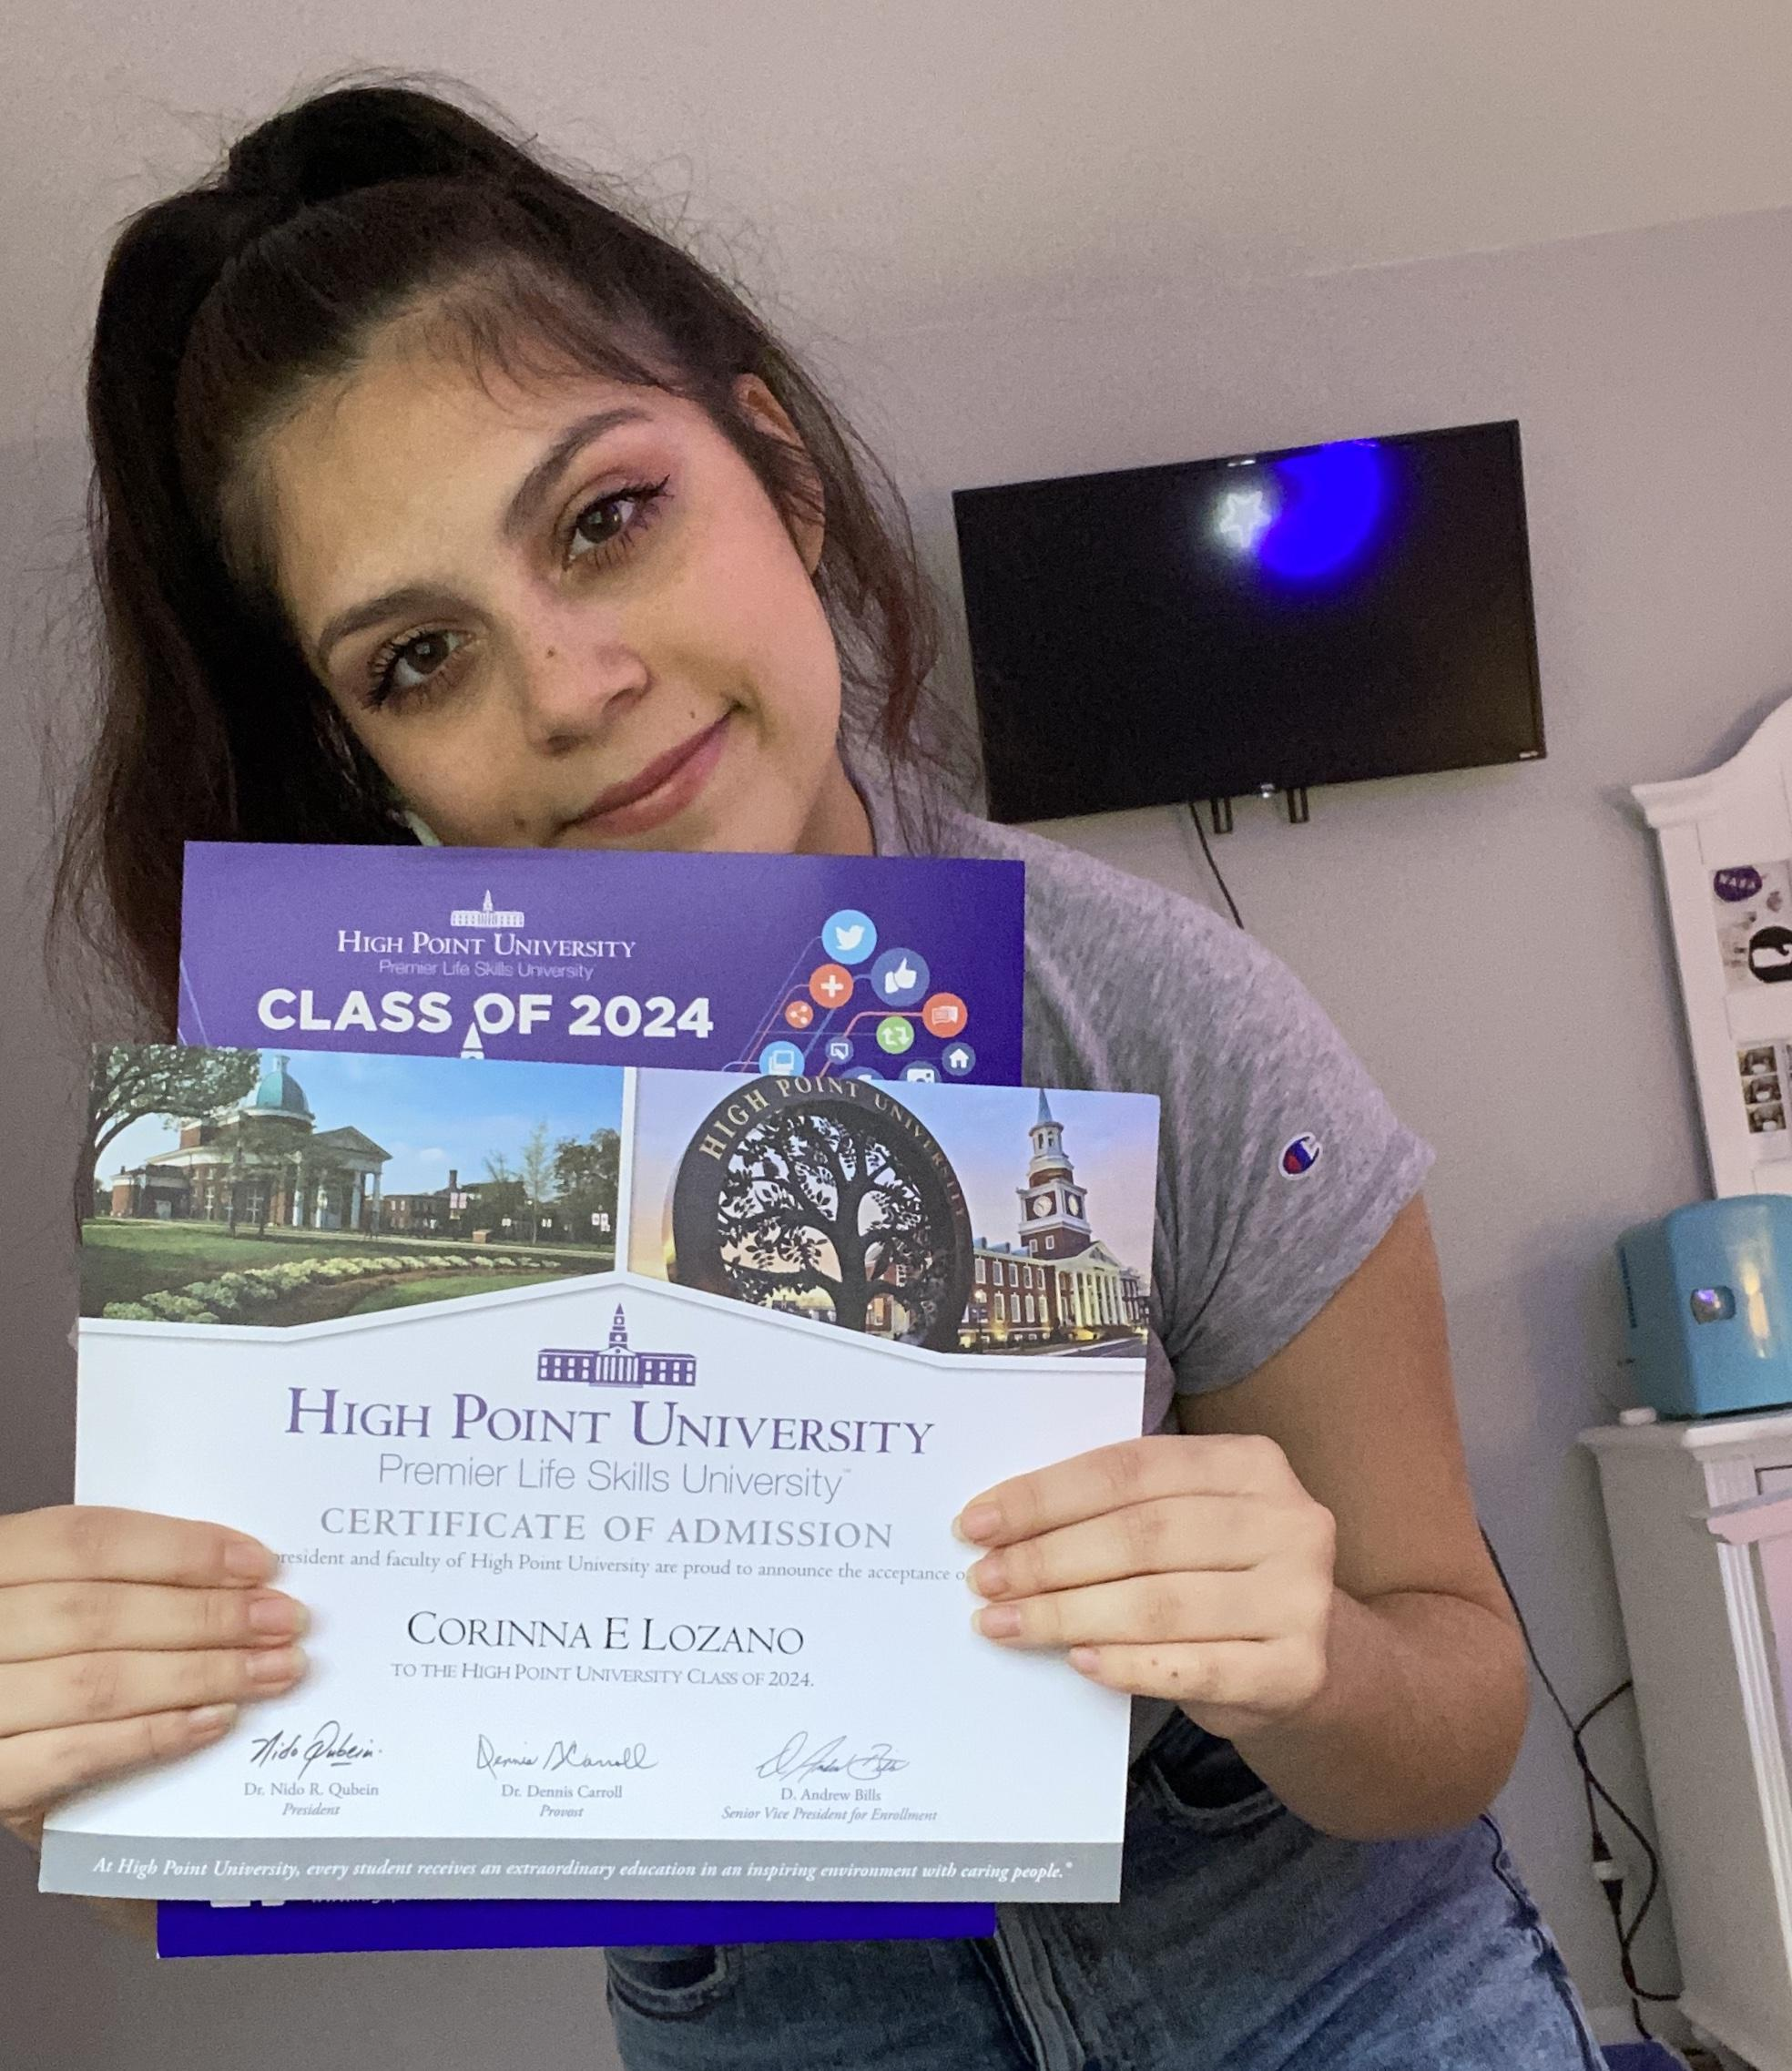
Years in Course: 3 (Senior)
Topic: Medicine & Health
Title: The Effects of 20-HETE Antagonism on Myocardial Infarction in
Metabolic Syndrome rats
Mentor: Dr. Petra Rocic PhD. New York Medical College

Biography:
Corinna Lozano is a senior and a third-year student in the Science Research program. Corinna is a member of Peer Leadership and the town of Pawling Interact Club. She is an active participant in Varsity Soccer and Varsity Dance team. Outside of school, she enjoys spending time with her family and volunteering within her community. She is extremely dedicated to her academic achievement and extracurricular activities. Corinna is very friendly and enjoys meeting new people through school programs. The teachers of Pawling High School know her for problem-solving and leadership skills.
In the last three years, she has participated in two cardiovascular conferences in Chicago and Los Angeles. She has completed research at NYMC with her mentor that focuses on the effects of 20-HETE and its correlation to heart attacks. Corinna plans on pursuing a degree in Biology on a Physician Assistant track. She will be attending High Point University in the fall and is super excited to get involved in research and on-campus activities.

Awards/Conference:
- 17th World Insulin Resistance Diabetes and Cardiovascular Disease Conference in Los Angeles
- 19th Annual Cardiology Conference in Chicago
- 31st Annual Association of Psychological Sciences Conference in Washington D.C. May 2019

