DNA/RNA/PROTEINS- FRQ’s
Genetically modified crops have been developed that produce a protein that makes the plants resistant to insect pests. Other genetic modifications make the crops more resistant to chemicals that kill plants (herbicides).
a) DESCRIBE TWO potential biological risks of large-scale cultivation and use of such genetically modified plants.

b) For each of the risks you described in part (a), PROPOSE a practical approach to reducing the risk.

Information flow in cells can be regulated by various mechanisms.
(a) Describe the role of THREE of the following in the regulation of protein synthesis:
- RNA splicing
- repressor proteins
- methylation
- siRNA

(b) Information flow can be altered by mutation. Describe THREE different types of mutations and
their effect on protein synthesis.

(c) Identify TWO environmental factors that increase the mutation rate in an organism, and discuss
their effect on the genome of the organism.

(d) Epigenetics is the study of heritable changes in the phenotype caused by mechanisms other than
changes in the DNA sequence. Describe ONE example of epigenetic inheritance.

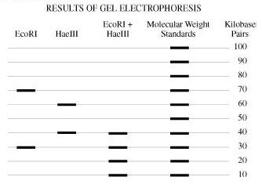
A bacterial plasmid is 100 kb in length. The plasmid DNA was digested to completion with two restriction enzymes in three separate treatments: EcoRI, HaeIII, and EcoRI + HaeIII (double digest). The fragments were then separated with electrophoresis, as shown.
a) Using the circle provided, CONSTRUCT a labeled diagram of the restriction map of the plasmid. EXPLAIN how you developed your map.

b) DESCRIBE how:
~ recombinant DNA technology could be used to insert a gene of interest into a bacterium

~ recombinant bacteria could be identified

~ expression of the gene of interest could be ensured

c) DISCUSS how a specific genetically modified organism might provide a benefit for humans and
at the same time pose a threat to a population or ecosystem

