DNA/RNA/PROTEINS- FRQ’s
2014 #5.
Genetically modified crops have been developed that produce a protein that makes the plants resistant to insect pests. Other genetic modifications make the crops more resistant to chemicals that kill plants (herbicides).
a) DESCRIBE TWO potential biological risks of large-scale cultivation and use of such genetically modified plants.
b) For each of the risks you described in part (a), PROPOSE a practical approach to reducing the risk.
2014 #8.
A research team has genetically engineered a strain of fruit flies to eliminate errors during DNA replication.
The team claims that this will eliminate genetic variation in the engineered flies. A second research team claims that eliminating errors during DNA replication will not entirely eliminate genetic variation in the engineered flies.
a) PROVIDE ONE piece of evidence that would indicate new genetic variation has occurred in the engineered flies.
b) DESCRIBE ONE mechanism that could lead to genetic variation in the engineered strain of flies.
c) DESCRIBE how genetic variation in a population contributes to the process of evolution in the population.
2013 The table below shows the amino acid sequence of the carboxyl-terminal segment of a conserved polypeptide from four different, but related, species. Each amino acid is represented by a three-letter abbreviation, and the amino acid residues in the polypeptide chains are numbered from the amino end to the carboxyl end. Empty cells indicate no amino acid is present.
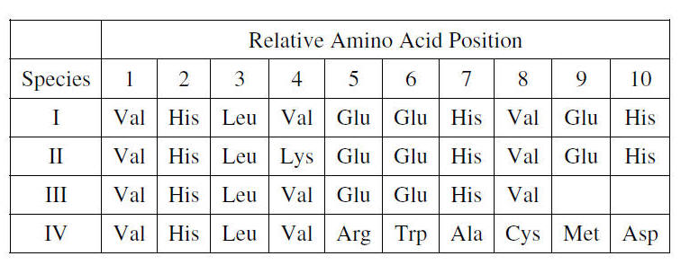
a) Assuming that species I is the ancestral species of the group, EXPLAIN the most likely genetic change that produced the polypeptide in species III.
b) PREDICT the effects of the mutation on the structure and function of the resulting protein in species IV. JUSTIFY you prediction.

2012 #3
Information flow in cells can be regulated by various mechanisms.
(a) Describe the role of THREE of the following in the regulation of protein synthesis:
- RNA splicing
- repressor proteins
- methylation
- siRNA
(b) Information flow can be altered by mutation. Describe THREE different types of mutations and
their effect on protein synthesis.
(c) Identify TWO environmental factors that increase the mutation rate in an organism, and discuss
their effect on the genome of the organism.
(d) Epigenetics is the study of heritable changes in the phenotype caused by mechanisms other than
changes in the DNA sequence. Describe ONE example of epigenetic inheritance.
2010 B #2
Certain human genetic conditions, such as sickle cell anemia, result from single base-pair mutations in DNA.
a) EXPLAIN how a single base-pair mutant in DNA can alter the structure and in some cases, the
function of a protein.
b) EXPLAIN, using a specific example, the potential consequences of the production of a mutant
protein to the structure and function of the cells of an organism.
c) DESCRIBE how the frequency of an allele coding for a mutant protein may increase in a population
over time.
2009 #4.
The flow of genetic information from DNA to protein in eukaryotic cells is called the central dogma of biology.
a) EXPLAIN the role of each of the following in protein p synthesis in eukaryotic cells.
~RNA polymerase
~Spliceosomes (snRNPs)
~Codons
~Ribosomes
~tRNA
b) Cells regulate both protein synthesis and protein activity.
DISCUSS TWO specific mechanisms of protein regulation in eukaryotic cells.
c) The central dogma does not apply to some viruses.
SELECT a specific virus or type of virus and EXPLAIN how it deviates from the central dogma.
2008 B
#3. Many biological structures are composed of smaller units assembled into more complex structures having functions based on their structural organization. For THREE of the following complex structures, describe the smaller units, their assembly into the larger structures, and one major function of these larger, organized structures
(a) A eukaryotic chromosome
(b) A mature angiosperm root
(c) A colony of bees
(d) An inner membrane of a mitochondrion
(e) An enzyme
2007 B #2
A molecule of messenger RNA (mRNA) has just been synthesized in the nucleus of a human cell.
a) What types of modifications may occur to this RNA before it leaves the nucleus?
b) Once in the cytoplasm, how is the mRNA translated to a protein?
c) If the cell is a secretory cell, how is the protein from part (b) eventually targeted, packaged, and
secreted to the exterior of the cell?
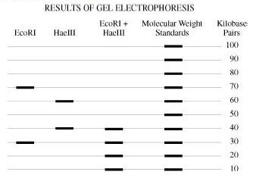
2007 #4.
A bacterial plasmid is 100 kb in length. The plasmid DNA was digested to completion with two restriction enzymes in three separate treatments: EcoRI, HaeIII, and EcoRI + HaeIII (double digest). The fragments were then separated with electrophoresis, as shown.
a) Using the circle provided, CONSTRUCT a labeled diagram of the restriction map of
the plasmid. EXPLAIN how you developed your map.
b) DESCRIBE how:
~ recombinant DNA technology could be used to insert a gene of interest into a bacterium
~ recombinant bacteria could be identified
~ expression of the gene of interest could be ensured
c) DISCUSS how a specific genetically modified organism might provide a benefit for humans and
at the same time pose a threat to a population or ecosystem

2006 #1
A major distinction between prokaryotes and eukaryotes is the presence of membrane-bound organelles in eukaryotes.
a) DESCRIBE the structure and function of TWO eukaryotic membrane-bound organelles other than the
nucleus.
b) Prokaryotic and eukaryotic cells have some non-membrane-bound components in common.
DESCRIBE the function of TWO of the following and DISCUSS how each different in prokaryotes and
eukaryotes.
~DNA
~Cell wall
~ ribosomes
c) EXPLAIN the endosymbiotic theory of the origin of eukaryotic cells and DISCUSS an example of
evidence supporting this theory.
2006B #2
The relationship of structure to function is one of the major themes in biology. For THREE of the following structure/function pairs, describe the structure and then explain how the function is related to the structure
a) Enzyme structure/catalysis
b) mRNA structure/protein synthesis
c) cell membrane structure/signal transduction
d) membrane protein structure/active transport or facilitated diffusion
2005 #2.
The unit of genetic organization in all living organisms is the chromosome.
(a) Describe the structure and function of the parts of a eukaryotic chromosome. You may wish to
include a diagram as part of your description.
(b) Describe the adaptive (evolutionary) significance of organizing genes into chromosomes.
(c) How does the function and structure of the chromosome differ in prokaryotes?
2005 B #3.
Protein synthesis is vital for cell growth and metabolism.
a) DESCRIBE transcription and translation.
b) IDENTIFY similarities between transcription and translation.
c) IDENTIFY differences between transcription and translation.
d) DESCRIBE structural changes that can occur to a protein after translation to make it function
properly
.
2003 B #1.
A difference between prokaryotes and eukaryotes is seen in the organization of their genetic material.
a) DISCUSS the organization of the genetic material in prokaryotes and eukaryotes.
b) CONTRAST the following activities in prokaryotes and eukaryotes.
- Replication of DNA
- Transcription or translation
- Gene regulation
- Cell division
2002 #1.
The human genome illustrates both continuity and change.
(a) Describe the essential features of two of the procedures/techniques below.
For each of the procedures/ techniques you describe, explain how its application contributes to
understanding genetics.
~ The use of a bacterial plasmid to clone and sequence a human gene
~ Polymerase chain reaction (PCR)
~ Restriction fragment length polymorphism (RFLP) analysis
(b) All humans are nearly identical genetically in coding sequences and have many proteins that are identical
in structure and function. Nevertheless, each human has a unique DNA fingerprint. Explain this
apparent contradiction
2002B #3
The physical form of cells and organisms is often influenced by special structural polymers.
Choose ONE polymer from EACH of the following three pairs of polymers
Pair 1: tubulin... myosin
Pair 2: cellulose . . . chitin
Pair 3: messenger RNA . . . transfer RNA
For each of the three polymers you have chosen, DESCRIBE it’s
a) structure and
b) role in a cell or organism
2001 #4
Proteins-large complex molecules-are major building blocks of all living organisms. Discuss the following in relation to proteins.
a) The chemical composition and levels of structure of proteins
b) The roles of DNA and RNA in protein synthesis.
c) The roles of proteins in membrane structure and transport of molecules across the membrane.
2000 #3.
Information transfer is fundamental to all living organisms. For TWO of the following examples, explain in detail how the transfer of information is accomplished.
a) The genetic material in one eukaryotic cell is copied and distributed to two identical daughter cells.
b) A gene in a eukaryotic cell is transcribed and translated to produce a protein
c) The genetic material from one bacterial cell enters another via transformation, transduction, or conjugation
1999 #4.
Scientists seeking to determine which molecule is responsible for the transmission of characteristics from one generation to the next knew that the molecule must
(1) copy itself precisely,
(2) be stable but able to be changed, and
(3) be complex enough to determine the organism's phenotype.
~ Explain how DNA meets each of the three criteria stated above.
~Select one of the criteria stated above and describe experimental evidence used to determine that DNA
is the hereditary material.

