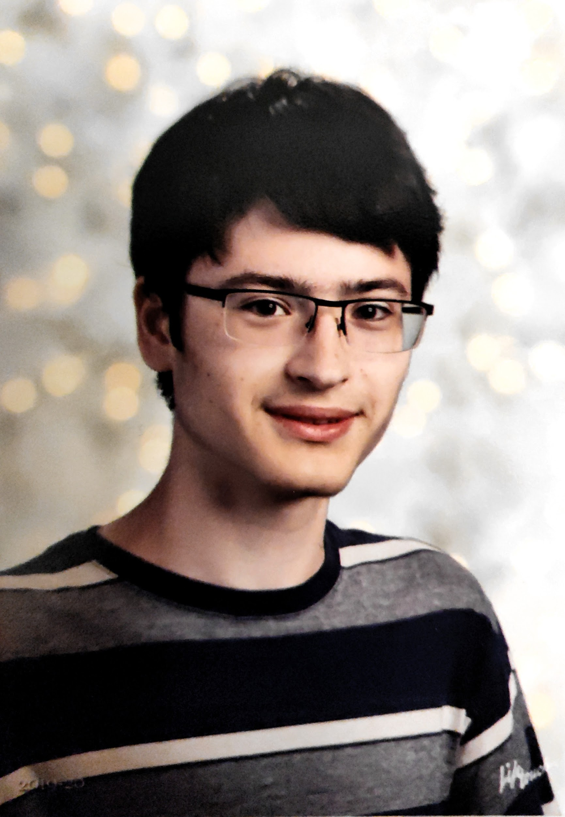
Name: Hayden Housen
Year in Course: 2nd (Junior)
Mentor: Dhirai Joshi, IBM
Title: Lecture2Notes: An automatic multimodal machine learning system to summarize lecture videos
Bio:

Hayden Housen is a junior at Pawling High School who is studying machine learning, computer vision, and natural language processing as part of the Science Research Program. He also is taking the most advanced classes offered to him, which creates a demanding workload. When Hayden is not studying for school or working on his research for Science Research, he is participating in various clubs and activities: In the fall he runs on the Cross Country team while in the winter he participates in mathematics competitions on the Math Team and skis for general enjoyment. Hayden hopes to pursue a degree in Artificial Intelligence or Computer Science in college.
Hayden is currently investigating an automated approach to summarizing lectures and slide presentations with a goal of being able to convert a presentation into detailed notes. This conversion is based on speech and the content on the slides. The computer learns which sections of the video contain unique slides and will extract the text off of them. Both the transcribed audio and slide content will be analyzed using a machine learning summarization algorithm developed by Hayden. Achieving automatic lecture summarization will be helpful to students and researchers in the machine learning field. This research necessitates a novel approach to document summarization which will be beneficial in future research that wishes to accomplish similar tasks. For the educational impact, there is evidence that the amount of information students record when taking notes has the largest impact of test scores. Additionally, when comparing the test scores of students that took their own notes to students that were provided notes from the teacher, no significant difference was found. Thus, Hayden’s research will save both professors and students time and enhance the learning process by providing them with a concrete starting point when learning from a lecture.

Awards/Achievements/Competitions:

- Somers 2019 Competition 3rd Place Computer Science and Mathematics

