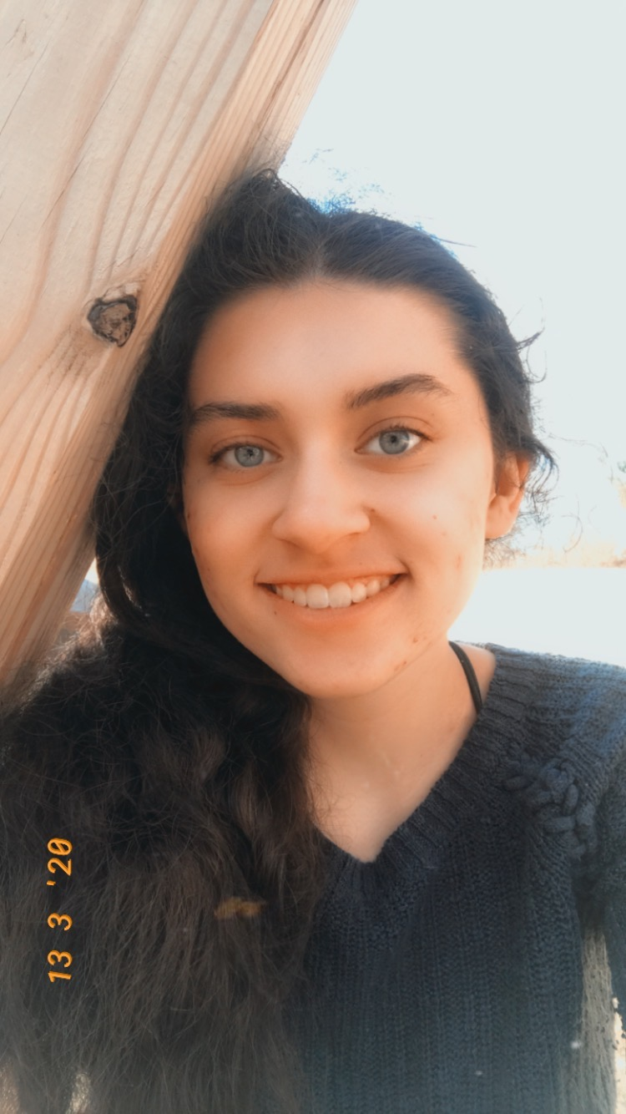
Karen Jackson

Year in Course: 3 (Senior)

Topic: Medicine & Health

Poster Titles: The Effect of Rapamycin Dosing on A Murine Model of Congenital Muscular Dystrophy Over a Trial of Six Months, The Effect of Autophagy Induction on the Replication Rate of the Zika Virus
Mentors: Dr. Aaron Beedle, Dr. Penghua Wang

Biography:
Karen is a writer and Science Research student with a focus in microbiology and infectious disease. She is a member of Science Honor Society and Literary Society, and she has written two novels and dozens of short stories in the genre of hard science fiction. Outside of science, she is also involved in art and has a passion for graphic design, and she has designed brochures, booklets and pamphlets for multiple events and symposiums. She has also been a manager of the Varsity Dance Team alongside Jacob Voudren for the past four years. She is a lifelong Girl Scout, and she has a passion for helping others and volunteer service.
Throughout her high school career, Karen has developed a passion for increasing scientific awareness and education and helping prevent future pandemics. In the fall, she will be attending the Albany College of Pharmacy and Health Sciences with a major in microbiology and a minor in public health. She will later be attending the New York Institute of Technology College of Osteopathic Medicine for a seven-year BS/DO program. She hopes to become an infectious disease specialist.

Awards and Honors:
Genius Olympiad Honors Award
Genius Olympiad Silver Award
Emily O’Neal Award for Effective Design
JSHS Bronze Award

