AP Capstone Seminar

Create a Graphic Organizer including Lenses and Perspectives using questions concerning each category as it relates to your topic.
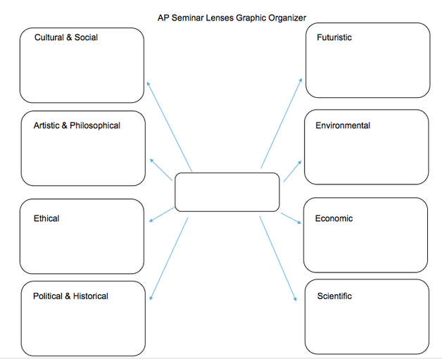

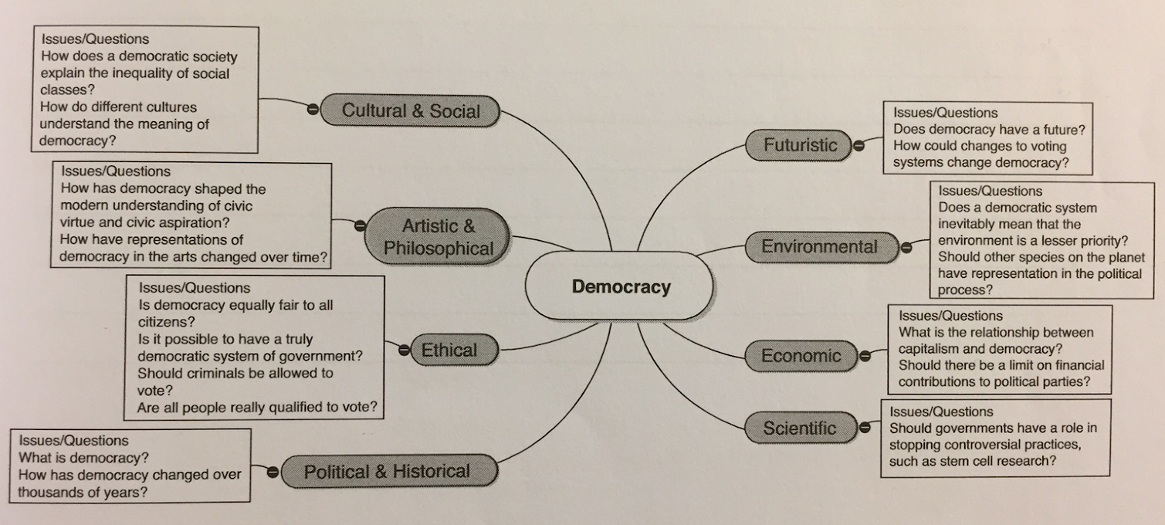

Notes:

