## Pawling Science Research

*In the science and technology driven world, science education is crucial in K-12 schools. The high school science research curriculum is especially important for students with a passion for science. It is designed to cultivate readiness in research skills in order to pursue a college degree or career in various science related fields.*

*In addition to high-level science courses, the high school science research program is instrumental in providing students with real world opportunities for developing skills necessary for a future career in science.*

Pawling High School

c/o: Gillian Rinaldo/Science Research

30 Wagner Road

Pawling, NY 12564

Pawling High School’s

Science Research Program

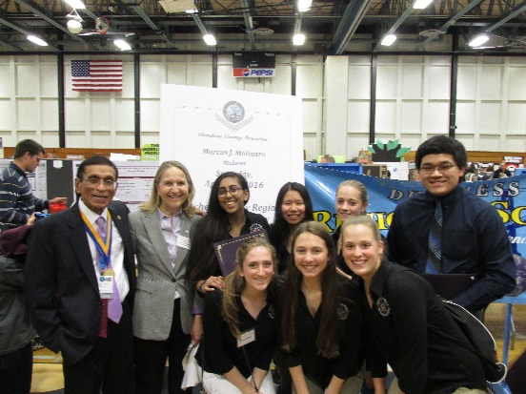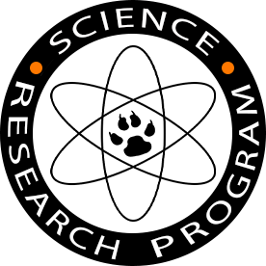

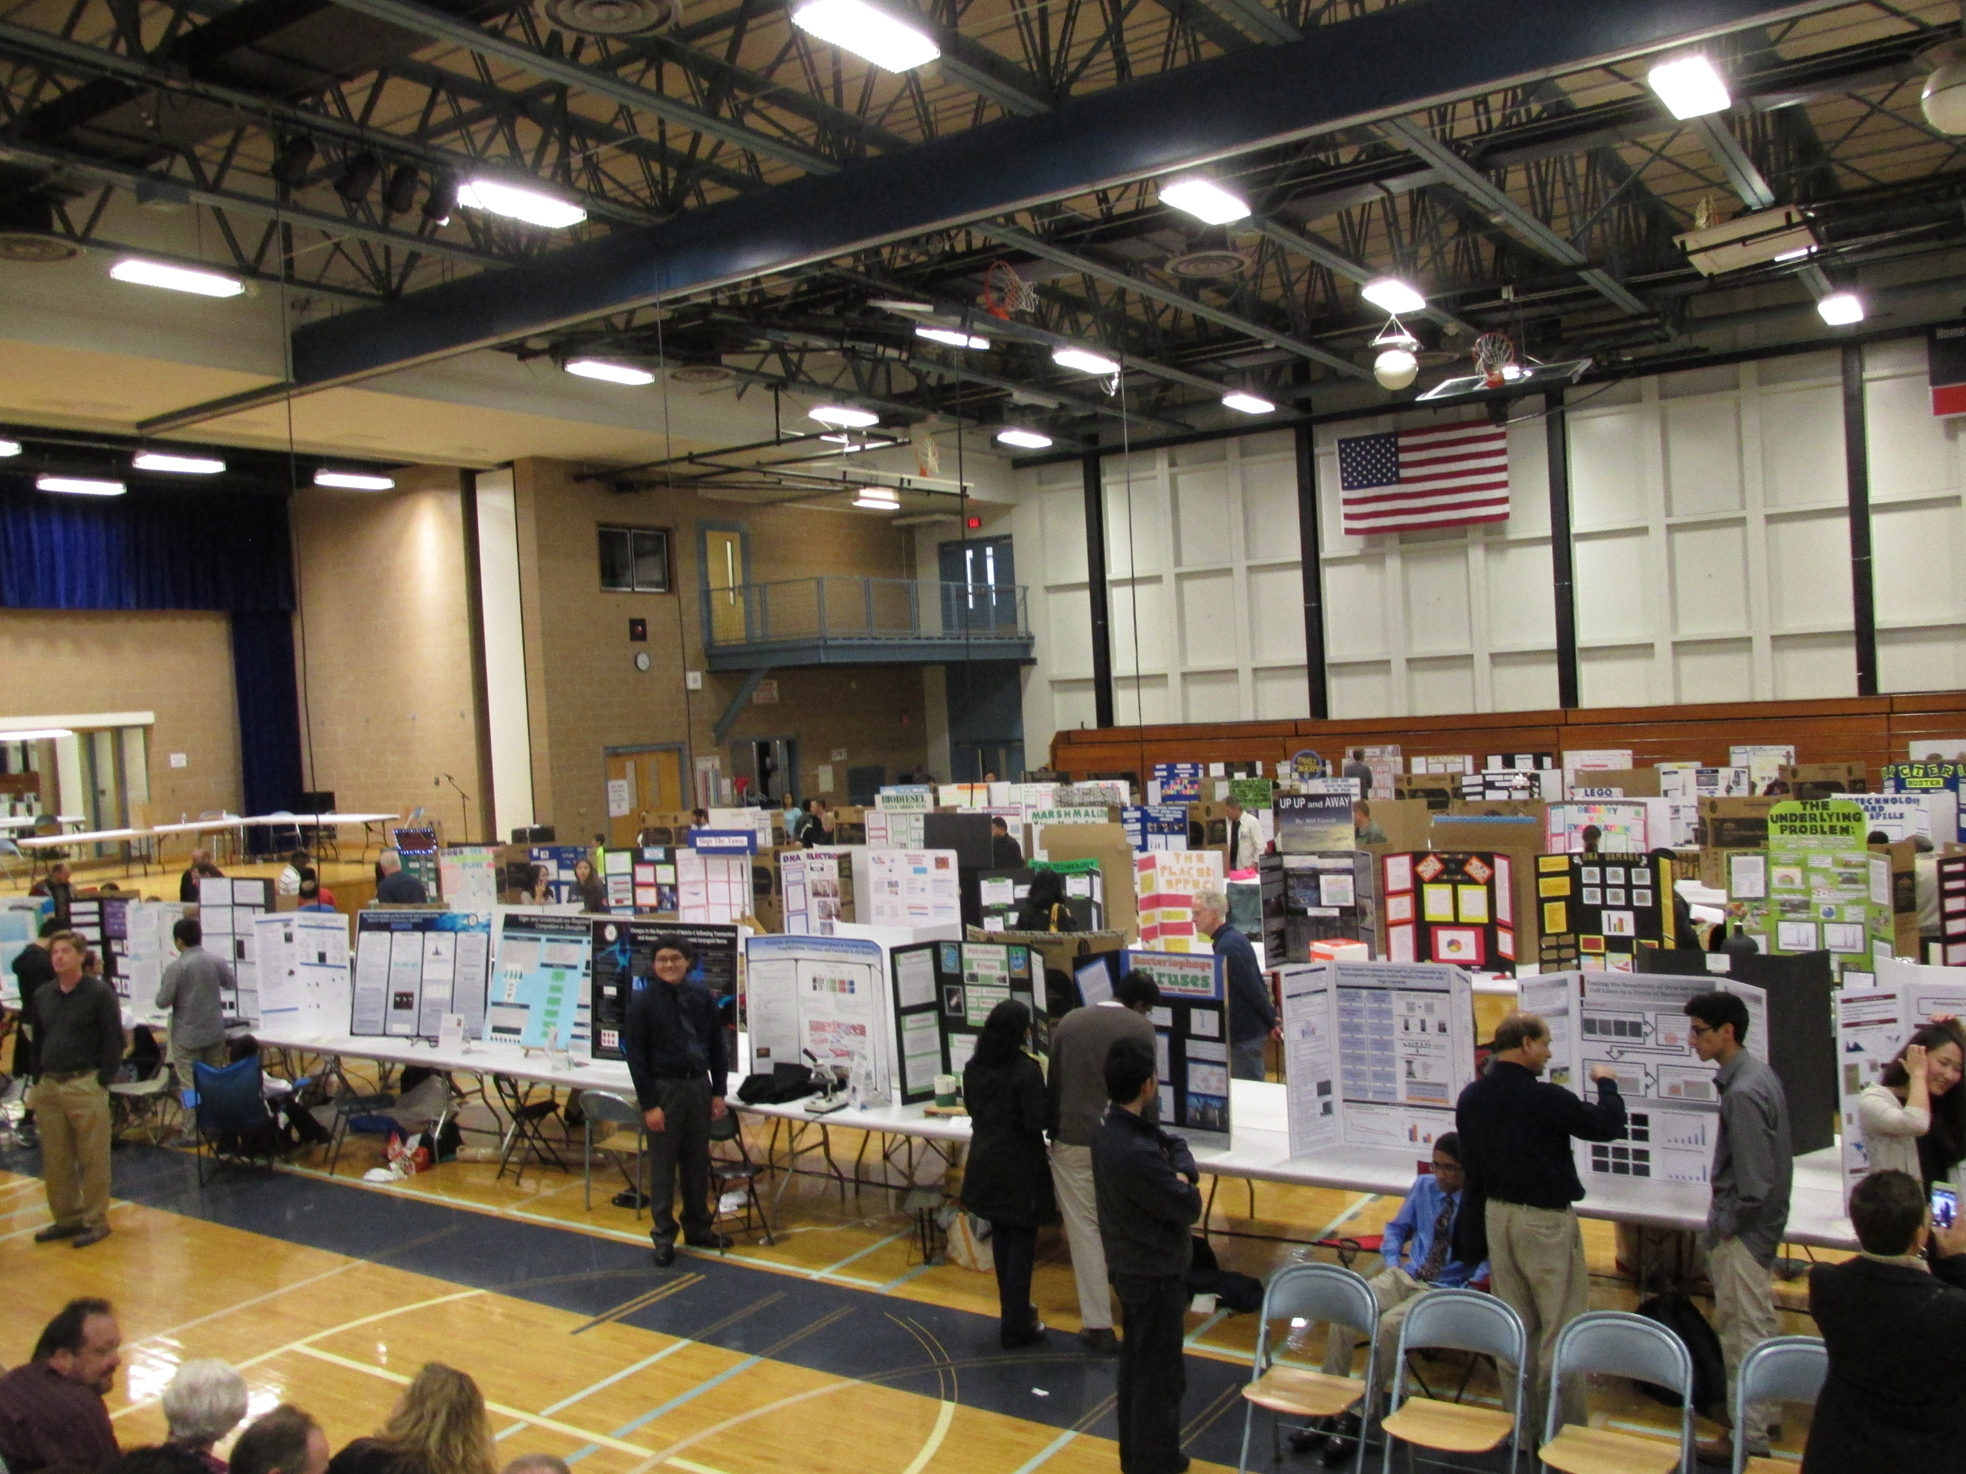

Phone: (845)855-4620

Web site: <http://www.pawlingschools.org/webpages/grinaldo/science_research.cfm>

Science Research Symposium

Providing Students the Opportunity to Participate in the Community of Science Research.

This course provides independent, self-motivated, keenly interested students an opportunity to experience authentic scientific research from start to finish. The course is designed to start sophomore year and involves a three year commitment for completion at the end of senior year. During sophomore year students are involved in bibliographic research and narrowing down the area of interest. They are introduced to technological on-line searching techniques and to methods for communicating directly with professionals in the chosen area of study. During this first year, they begin learning skills associated with making both oral and poster presentations. While working with a professional mentor, junior year involves creating an experiment, and becoming familiar with statistical techniques during the analysis of data. Senior year is devoted mainly to writing their paper and preparing for presentation at local, regional, and state science symposia and student research competitions. Students may elect to receive college credits for this class through the University in the High School Program at SUNY Albany.

## Course Description

# Science Research Overview

* Siemens Competition
* Intel Science Talent Search
* ISWEEP Competition
* Dutchess County Regional Science Fair
* Eastern New York JSHS
* New York State Science and Engineering Fair
* Intel International Science and Engineering Fair (Intel-ISEF)
* Google Science Fair
* Westlake Science Fair
* Pawling High School’s Science Research Symposium

## Competitions

The Pawling High School Science Research Program offers students the opportunity to participate in authentic science research as part of their high school experience. It furthers excellence in performance and achievement, while drawing from and developing scientific capabilities.

Students taking the course:

* Choose and explore a topic of interest.
* Develop research skills using the internet and conduct searches of scientific databases.
* Locate and study scientific journal articles.
* Learn to present scientific research.

To accomplish these goals the students locate mentors and with the help of their mentors, design and carry out their own original research. The progress of all students is systematically monitored and assessed to ensure that they effectively engage in each phase of the science research process, acquiring the desired skills, experience, and personal growth. The course culminates with the students presenting their work in local, state and national competitions.

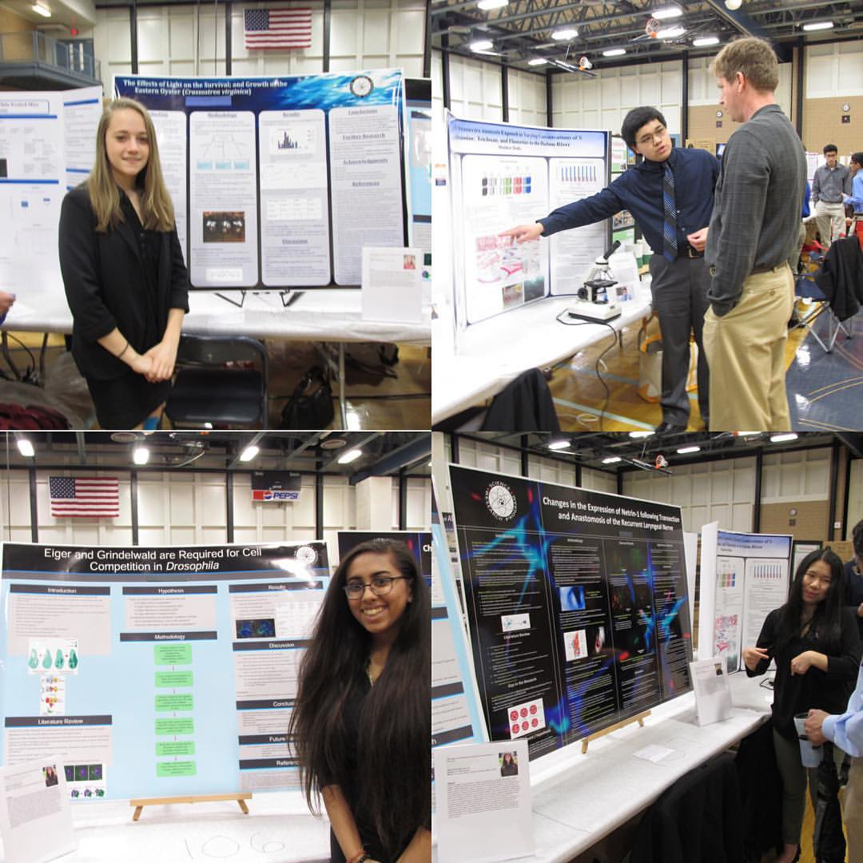

Pawling High School’s

Science Research Program

Gillian Rinaldo

30 Wagner Road

Pawling, NY 12564

Phone: (845)855-4620

E-mail: [Rinaldog@pcsdny.org](mailto:Rinaldog@pcsdny.org)