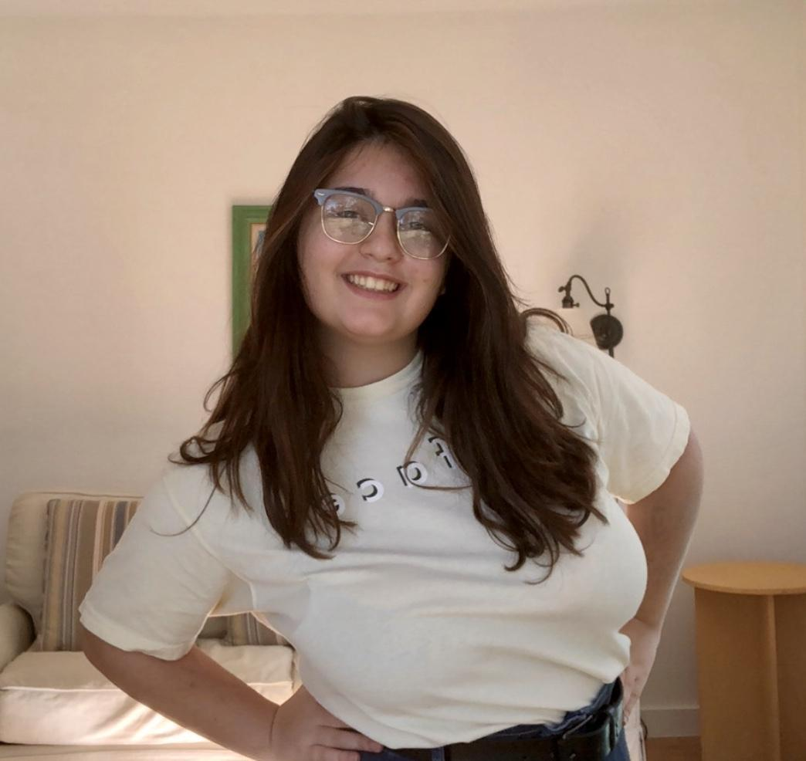

Name: Lauren Radicchi
Year in Course: 2nd (Junior)
Topic: Adolescent Psychology, Sleep, Memory, and Technology Use
Mentor: Dr. Anna Schapiro, University of Pennsylvania
Title: The Impact of Technology Use before Sleep and its Effects on Implicit and Explicit Memory Retention
Bio:
Lauren Radicchi is a junior at Pawling High School and has worked very hard during her second year within the Science Research Program. She has taken on a rigorous course load during this school year, including 2 AP classes, and she hopes to push herself in order to understand the importance of perseverance even more. She became interested in psychology when she was in middle school, and taking new courses in high school has intensified her love of the subject material. When Veronica is not intensely studying, she is taking part in one of many clubs. Lauren is a part of five clubs in the high school, including Chess and Mock Trial. It is here she learns teamwork skills and skills such as confident public speaking. In addition to clubs, Lauren has a position at the Pawling Record, as an editorial intern. Throughout the year, she writes stories about her community to publish in the paper. She helps different parts of the school such as the dance team and Health and Wellness Committee promote events and community service opportunities. Lauren hopes to pursue a career in cognitive science and aspires to continue psychological research as an adult.
Even before she entered the Science Research Program, Lauren knew she wanted to study psychology and cognitive science. After reading many peer-reviewed journal articles, she realized she was very interested in sleep studies, as well as the causes of abnormal sleep. After investigating this topic area, Lauren decided to explore how technology use before sleep impacts memory in adolescents, something which there is very little research about to date. Therefore, she set out to test adolescents using similar adult testing methods in order to see how the use of technology with a screen interface impacts sleep and memory. Lauren is currently conducting her methodology using the Oura rings that she purchased which accurately measure sleep quality and duration. Additionally, she is gathering survey information and sleep diaries to further expand our current understanding of sleep quality.

Awards/Achievements/Competitions

- Somers 2019 Competition 3rd place in Behavioral Science

