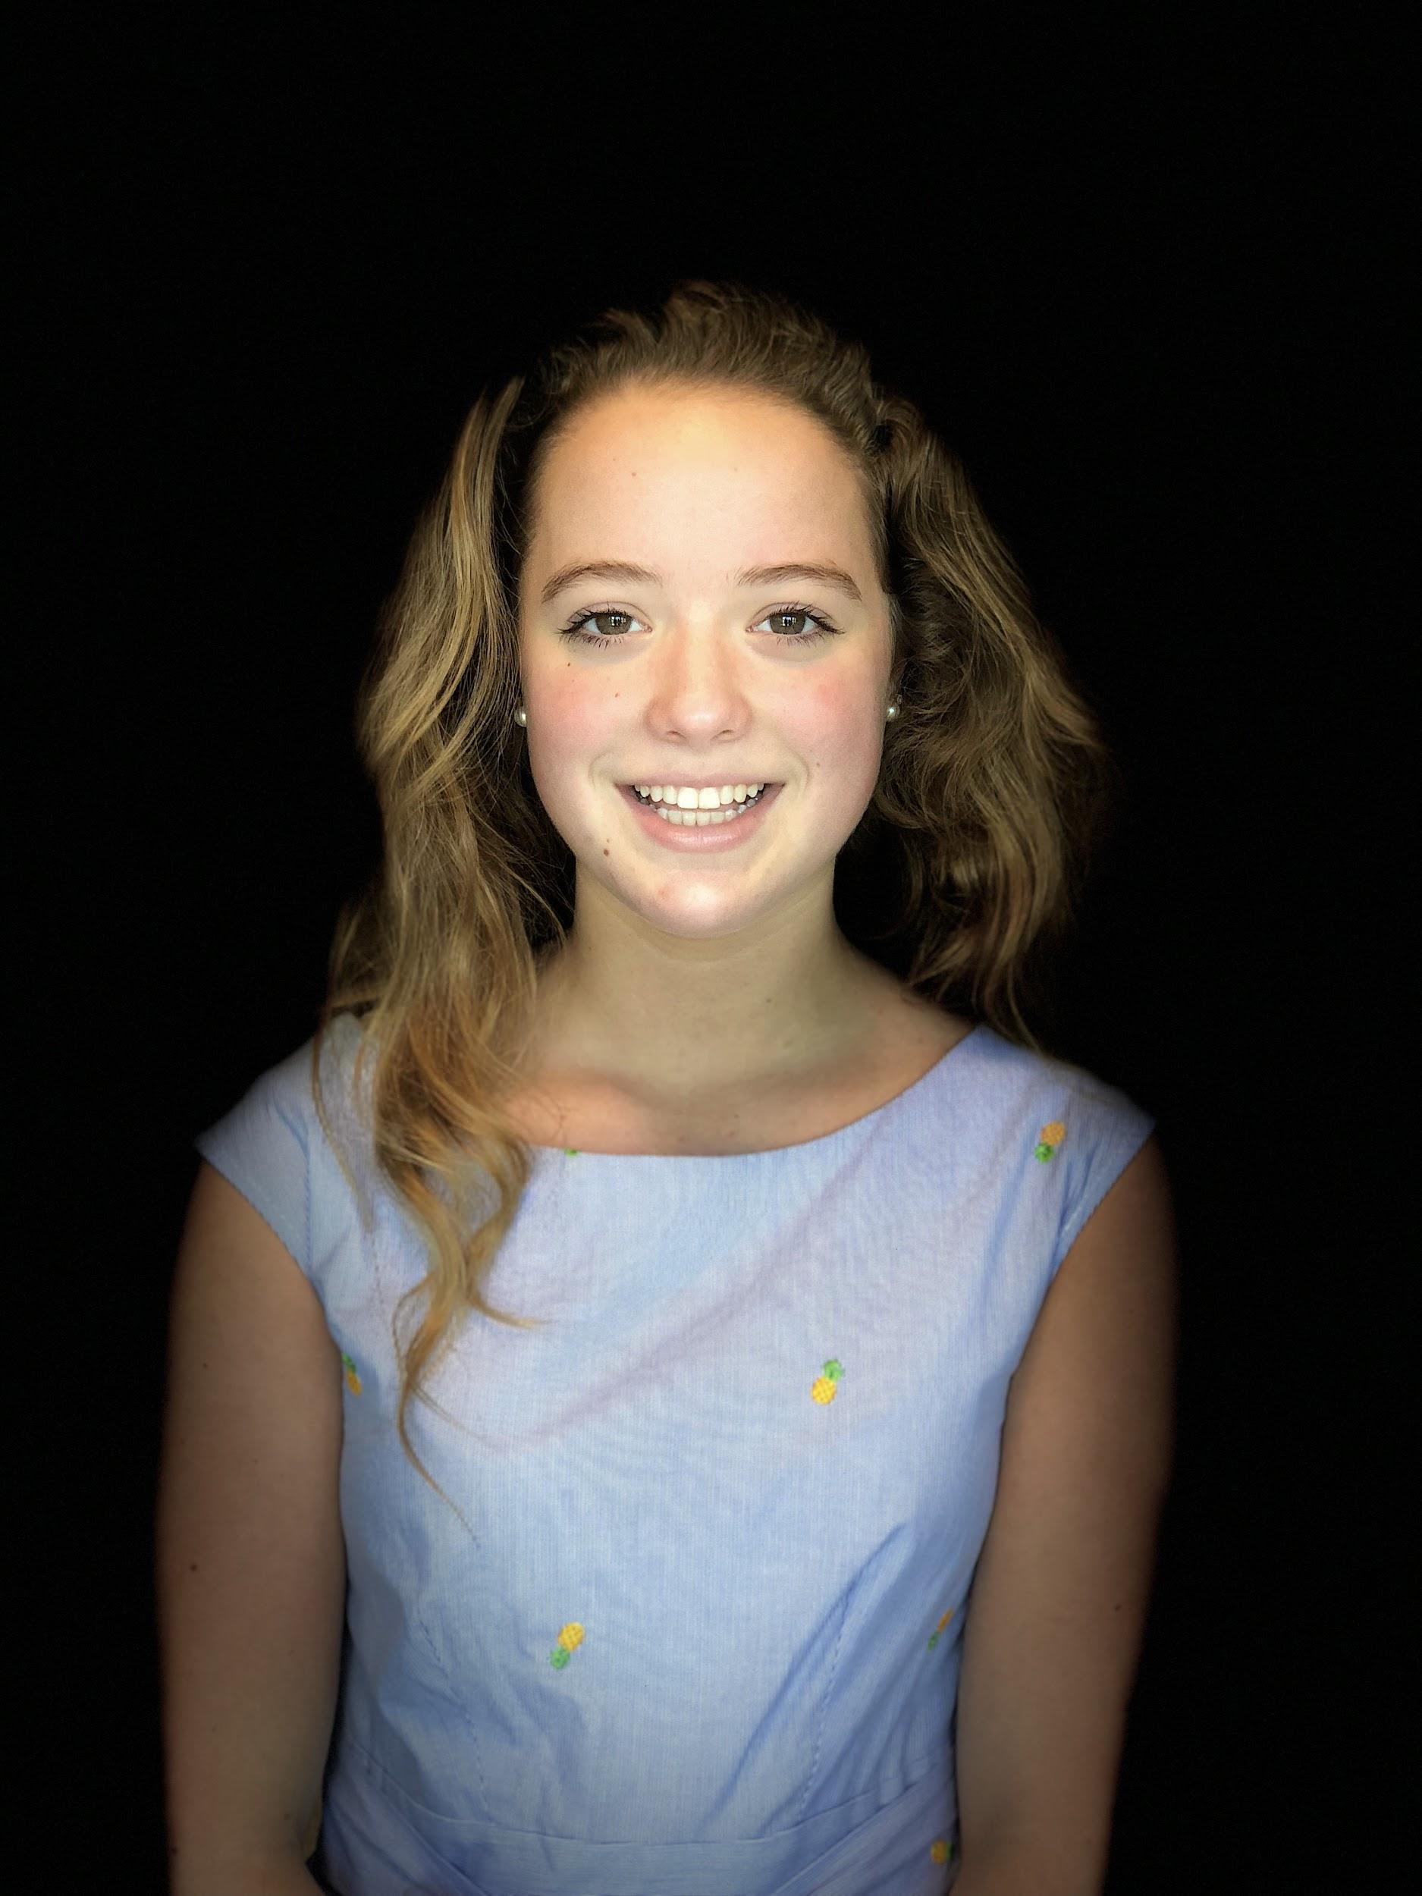
Name: Ellie Farquhar
Year in Course: 3 (Senior)
Topic: Shark-Human Interaction
Poster Title: The Effects of Coloration on the Swimming Patterns of Carcharhinus perezi
Mentor: Dr. Erich Ritter; U West Florida & SharkSchool

Bio:

Ellie Farquhar is a senior at Pawling High school who has thoroughly enjoyed the opportunities Pawling High School’s science research program has offered her. She feels lucky to have been able to pursue the field of shark behavior as it relates to human presence in the water, and has enjoyed learning more about her chosen topic while simultaneously honing her public presentation skills. She has had the opportunity to travel within the United States and present her findings at a number of marine conferences among specialists in the field. Ellie’s favorite classes by far revolve around science which largely influenced her decision to join the science research program and continue to motivate her plans to pursue a degree in marine biology at the University of Florida, Gainesville this fall.
Throughout her high school career, Ellie has been a member of the Varsity Field Hockey team, while also participating in the French and Science National Honors Societies. When she is not in school, Ellie enjoys working out, traveling, diving, reading, and adventuring.

Awards/Honors
- 1st Place at Eastern JSHS 2019
- 3rd Place at Upstate NY JSHS 2019
- Speaker at UC Berkeley’s 2019 Bay Area Conservation Biology Symposium
- Accepted for UC Berkeley’s 10th International Conference on The Constructed Environment
- Accepted for the 2019-2020 Animal Behavior Society Symposium in NYC

