AP BIOLOGY

NAME-----------------------------------------------------------------------

INTRODUCTION TO CELLULAR DIVISION
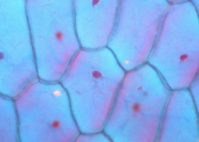 What do you remember about Mitosis and Meiosis?

What is the purpose of mitosis?

What is the purpose of meiosis?

What is the result of mitosis?

What is the result of meiosis?

In order to maintain the correct number of chromosomes for a species, what event must take place prior to cell division?

What are the stages of mitosis?

What are the stages of meiosis?

Which phase do cells spend the most of the time in?

What can happen when certain checkpoints malfunction during the cell cycle?
.
How does meiosis contribute to the genetic diversity of a population/

How are the cells produced by meiosis different from their parent cells?

