CHAPTER EIGHT – THE ENDOCRINE SYSTEM

Lesson 8.1
Anatomy of the Endocrine System
- Endocrine system –

- Endocrine glands –

- Exocrine glands –
-

Hormones
- Two types of hormones:
- steroid hormones–

- amino acid hormones–

- hormone receptors –
Epinephrine –

  - Upregulated– Downregulated -
- Exercise –

- Obesity and inactivity –
Hormone Secretion Control (Regulation)
- neural control-

  - Fight or flight –

- hormonal control –

  - hypothalamic-releasing hormone –

- Humoral Control:

- E.G. –

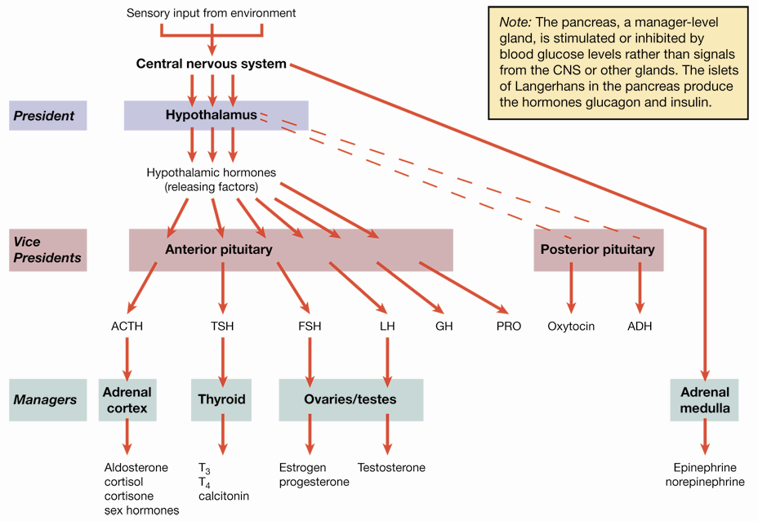
Hormone Secretion Control
- negative feedback
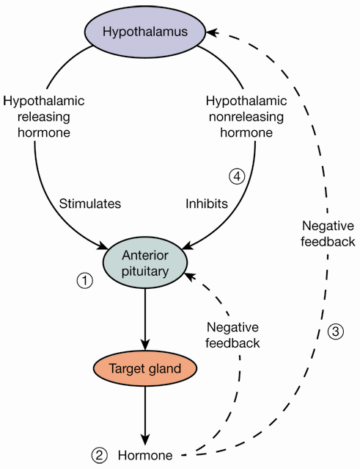
The Hypothalamus
- helps regulates body temperature
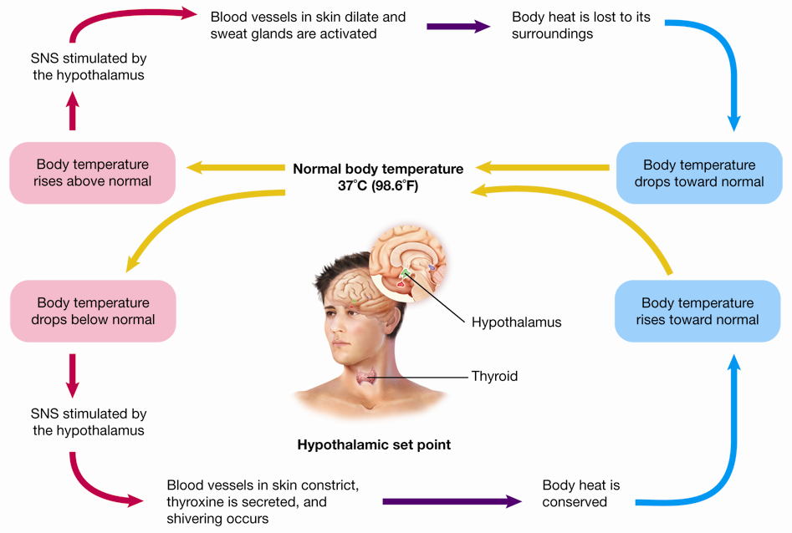
Lesson 8.2
Major Endocrine Organs
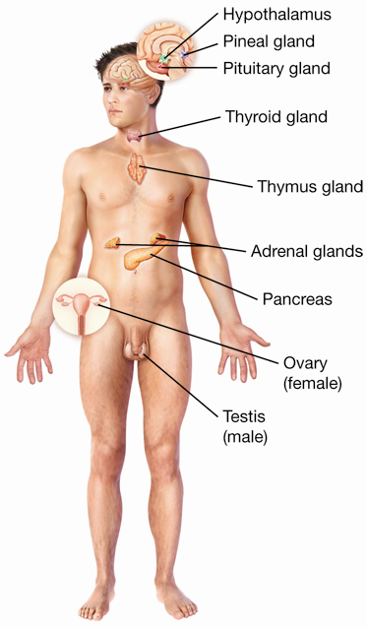
The Hypothalamus (Nervous and Endocrine System)

- helps regulate

The Pituitary Gland

- Hormones function in two ways:

OR:

Hormones of the Anterior Pituitary: 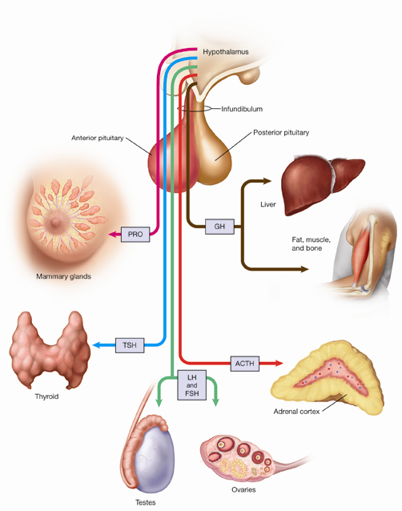

- prolactin (PRO) –

- growth hormone (GH) –

Hormones of the Anterior Pituitary
These 4 are tropic hormones:
- adrenocorticotropin hormone (ACTH)

- thyroid-stimulating hormone (TSH)

- follicle-stimulating hormone (FSH)
    - Females -

- Males -

- luteinizing hormone (LH)
  - in females -

  - in males -

Hormones of the Posterior Pituitary –

Stores rather than produces hormones:
- Antidiuretic hormone – ADH -

- Oxytocin –

-

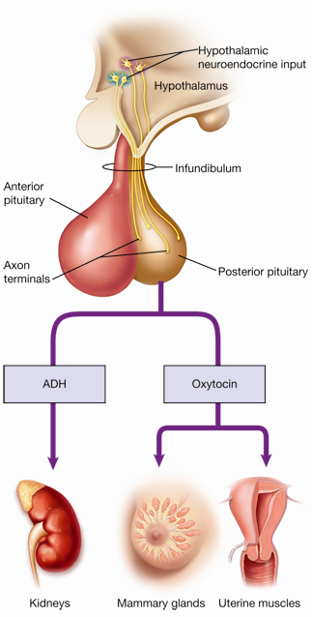
Major Endocrine Glands
- Thyroid gland-

  - Thyroxine

Also Produces:
  - Calcitonin –

- Parathyroid gland –
  - parathyroid hormone –

- Thymus gland –
  - thymosin

- Pineal gland-
  - melatonin
    - 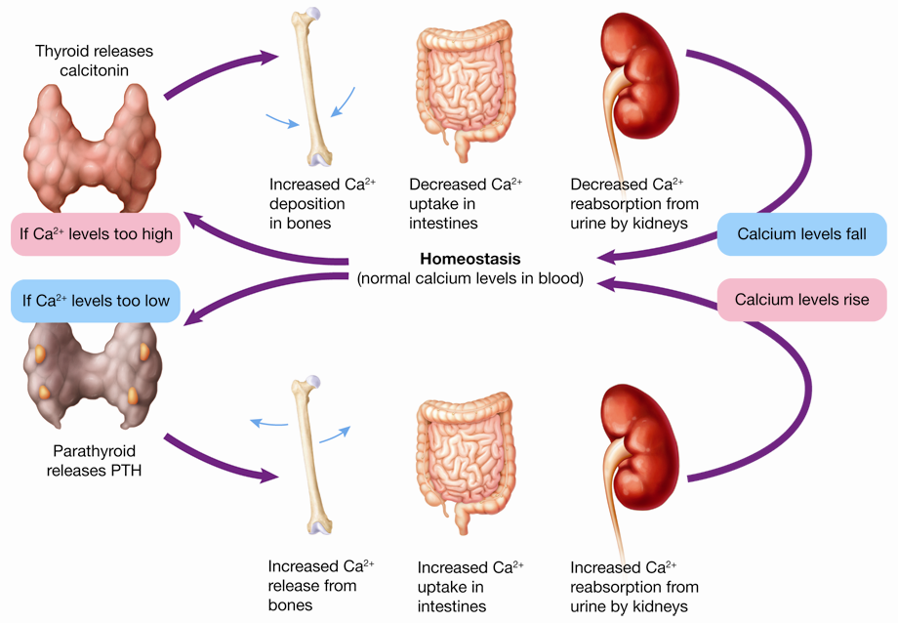

- Adrenal Glands –
  - Adrenal medulla –
  - Epinephrine (adrenalin) and norepinephrine

- Adrenal cortex –
  - Mineralocorticoids
    - Aldosterone –

  - Glucocorticoids
    - cortisone and cortisol –
    - promote gluconeogenesis –
Sex hormones –

- Adrenal Glands:
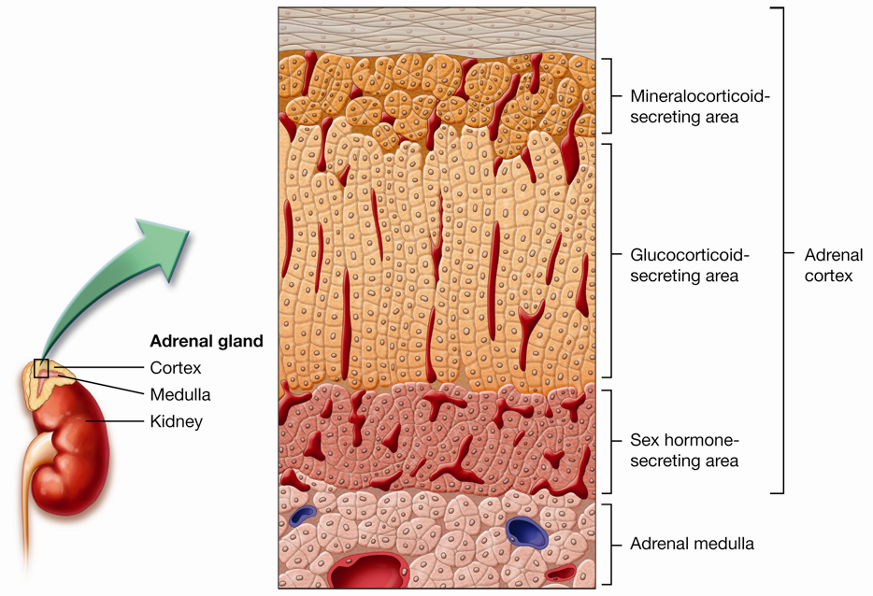
- Pancreas –
It also secretes digestive enzymes
- Islets of Langerhans –
  - alpha cells

  - beta cells

These hormones target every cell in the body
- Gonads –
- Testes- located in the scrotum

- Ovaries- located in the female pelvic cavity
  - Estrogen and Progesterone

- Other Hormones
Kidneys – secrete Erythropoietin

Fatty tissue – secretes prostaglandins –
Also: Leptin-
Lesson 8.3 – Endocrine Disorders and Diseases
Pituitary Disorders
- Hyperfunction –

- Hypofunction-

  - diabetes insipidus –
  - Diabetes mellitus –

Thyroid Disorders
- Hyperthyroidism –
  - Goiter –
  - Graves disease –

- Hypothyroidism –
  - Myxedema –
  - neonatal hypothyroidism –
Endocrine Disorders and Diseases
- disorders of the parathyroid gland
  - Hypercalcemia –

  - Hypocalcemia –

- adrenal medulla disorders
  - Pheochromcytoma –

- Disorders of the Adrenal Cortex
Cushing syndrome
-

- Addison’s disease

The Pancreas and Diabetes Mellitus
symptoms of diabetes mellitus

  - polydipsia

  - polyphagia

Types of Diabetes
- type I diabetes mellitus - (only 5-10%)

- type II diabetes mellitus – (90-95%)

-
Diagnosed -
Other symptoms:

