AP Biology – Ms. Baker

NAME_____________________________________________________

GEL ELECTROPHORESIS VIRTUAL LAB 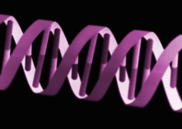

Answer the following questions as you move through the lab exercise.

- What does Gel Electrophoresis do to DNA?

- What other molecules is it used for?

- What is the purpose of the gel?

- Where do you put the DNA samples?

- How do the DNA strands sort themselves?

- How do we make the strands more visible?

- What are the steps in running a gel?

- What do you need to run a gel?

- What is agarose?

- What is the buffer used?
- Why do you put plastic wrap over the flask?

- What does the comb do?

- What does the buffer do?

- What do you need to load the DNA sample?

- What is the size standard used for?

- What does the electric current do?

- Where should the short and long strands end up?

- What stain do we use and what does it do?

- Determine the approximate length of all your DNA strands.

- Check your answers.

