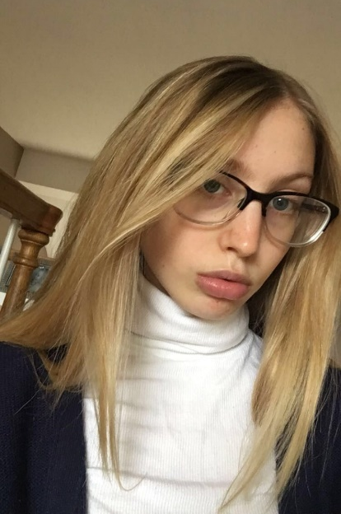
Name: Kendall Arnold
Year in Course: 1st (Sophomore)
Topic: Coral Reef Restoration, Counteracting the Negative Effects of Climate Change, Finding Effective Restoration Techniques
Mentor: Dr. Orion McCarthy, Scripps Institution of Oceanography UC San Diego
Title: Effects of Climate Change on Coral Reefs and Restoration Efforts
Bio:

Kendall Arnold is a sophomore at Pawling High School and has put a lot of work into developing her research since she started the Science Research Program. This year, she has involved herself in advanced classes, including AP Capstone Seminar, Chemistry, and Global II Honors as a sophomore. She hopes to continue to push herself in her education and curriculum in her upcoming high school years and beyond. Ever since she was a young girl, Kendall has been fascinated by the ocean and everything in it, so she always knew that she wanted to pursue a career in marine biology. Science research has offered her an amazing opportunity to build her knowledge on the subject. When Kendall is not focusing on school, she is participating in sports. She plays on two varsity teams: field hockey in the fall and lacrosse in the spring, and participates in dance outside of school. Field hockey is what she enjoys most, having fallen in love with the sport when she first started playing in 7th grade. Kendall is also a member of the Peer Leadership Club and helps plan and help with community events, and she is the treasurer and secretary of the National French Honor Society. In the future, Kendall hopes to attend a college with a good marine biology program in a warm environment. She aims to be a marine biologist and be able to spend her life studying what she loves: the ocean.
Kendall became passionate about studying coral reef restoration two years ago when she watched a documentary called “Chasing Coral.” This documentary detailed the abnormal loss of coral reefs on a rapid, global scale. While watching it, Kendall realized how important coral reefs are to marine biodiversity and to the human population, and that losing them would prove to be detrimental to various ecosystems. This was when she decided on what she wanted to pursue in the Science Research course. From the beginning of the school year to now, Kendall has immersed herself in the world of coral reef restoration by reading numerous journal articles and reaching out for more information from experts in the field. She is studying different techniques and strategies that are used to restore coral and how both local and global factors are affecting the health of reefs. Kendall hopes that with the research she conducts, she will be able to contribute to the rehabilitation and preservation of coral reefs for future generations. She cannot wait to begin her research and find out how these vital ecosystems can be helped further.

Awards/Achievements

- Field Hockey All-League Player Fall 2018
- Lacrosse All-League Honorable Mention Spring 2018
- Field Hockey All-Elite Player Fall 2019

