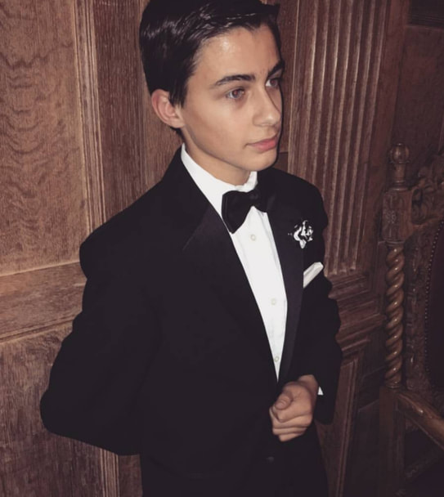
Name: Robert (Robbie) Leske
Year in Course: 2nd (Junior)
Topic: Physical Chemistry, Quantum Biology, Chemical Simulations
Mentor: Dr. Raymond Kapral, University of Toronto; Dr. Dennis Salahub and graduate students, University of Calgary
Title: A Combined Quantum Mechanics and Molecular Mechanics Simulation of the Chlorophyll Complex Involved in Photosynthesis
Bio:
Robbie Leske is a junior in the Pawling Science Research Program in the field of quantum chemistry. He has worked hard in science research and his other classes. This year he has taken on 4 AP classes, his favorites being physics and computer science. His love for science began with an admiration for chemistry and astronomy but has grown thanks to the courses he was able to take at Pawling High School. Robbie has also participated on the varsity cross country team in the fall as well as the math team for the past three years. On the math team this past year, Robbie qualified for the math team sectionals alongside some of his team mates. This year, he joined the mock trial club as the lead prosecution attorney. Outside of school, Robbie is on a competitive baton twirling team with which he travels around the country for both team and individual events. Three years ago, Robbie qualified for the USA baton twirling team for his 2-baton solo. He competed at the worlds competition and finished 3rd in the world. He qualified again this past summer for 3 events: 1-baton, 2-baton, and rhythmic. However, due to the covid-19 pandemic, the world competition was pushed back. Robbie is looking to go to college at the Georgia Institute of Technology for physics. Additionally, he hopes to twirl for the Georgia Tech Marching Band while in college.
Robbie’s love for physics comes from a love to break things down and understand the most basic parts of the system. For this reason, he also enjoys chemistry. Robbie is currently in the field of quantum chemistry which marries physics with chemistry in order to gain a better understanding of the governing principles of both to make more accurate predictions and understand macroscopic effects of quantum mechanics. He is researching the efficiency of electron transfer in the photosystems involved in photosynthesis. The efficiency of photosynthesis has long baffled scientists. The best assumptions for the reason for this efficiency involve quantum phenomena such as quantum tunneling and superposition, which allows the electron to travel through many paths from the photoreceptive protein to the reaction center. In his research, Robbie will use quantum chemical simulations to model the photosystem in order to compare his results to experimental results presented in previous research. If his data matches experimental results, it would suggest that our current knowledge of quantum mechanics and our predictions in the field of quantum biology are highly accurate.

Awards/Achievements/Competitions

- Somers 2017 Competition
- 3 Sport Athlete with over a 100 Cumulative Average

