Name:

Define the following: *Please use any font color other than black to write your responses below*

- Matter:
- Compound:
- Heterogenous:
- Homogeneous:
- Kinetic Energy:
- Potential Energy:
- E=mc²

Types of Energy-

Mechanical

Chemical

Nuclear

Thermal

Electromagnetic

Radiant

Electrical

Radiant/Solar

Gravitational

Describe the Law of Conservation of Energy:

Describe the Law of Conservation of Matter:

States of Matter:

Solid-

Liquid-

Gas-

Plasma-

Describe the Life Cycle of a Star:

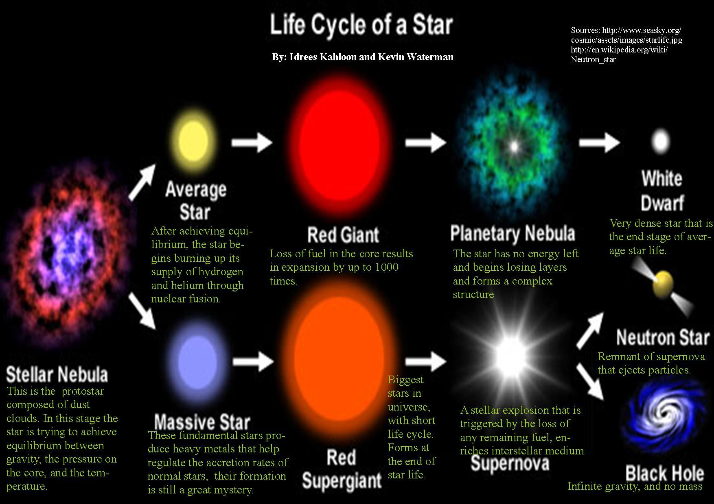

Big Bang Theory:

When-

Galaxy:

Light Year:

Doppler Shift:

Nuclear Fusion in Stars:

Cosmic Radiation

Dark Matter:

