Name: Date:
Environmental Science Ms. Rinaldo

Matter and Energy

Matter

- Matter :

- Element:

- Compound:

- Heterogeneous:

- Homogeneous:
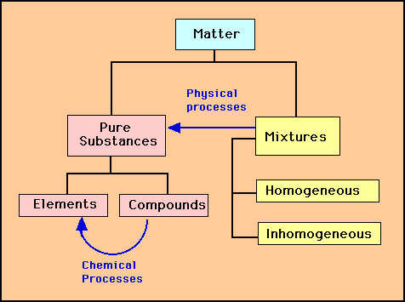

Law Conservation of Matter

- In any physical or chemical change, matter

- Matter can be

- How did all of the matter that exists in the environment, get there?

Scientists Theory of the Timeline of Our Universe

Law Conservation of Mass

Kinetic Molecular Theory:
- The molecules are in

- This motion is different for the

  - ( bonds)
  - ( bonds)
  - ( bonds)
  - ( )

Solid

Liquid

Gas

Plasma

Energy –

What is mechanical energy?

- Two General Types

  - Potential –

  - Kinetic –

Forms of Energy

  - Mechanical –

  - Electromagnetic –

  - Electrical-

  - Chemical-

  - Thermal -

  - Sound – the movement of energy through substances in longitudinal (compression/rarefaction) waves

  - Nuclear – the use of exothermic nuclear processes to generate useful heat and electricity. This includes nuclear fission, nuclear decay, and nuclear fusion

Energy Conversions
- Efficiency –

Law of Conservation of Energy

How do scientists theorize that the universe was created?

Name: Date:
Environmental Science Ms. Rinaldo

The Big Bang Theory
The Universe

- May be home to more than
  - Galaxies
    - Each Galaxy with Trillions of Stars
- About Years Ago
  - All pro-matter and energy condensed due to gravity ( )……
- This BANG formed the Universe…..and all galaxies, stars, and planets
- Gravity
- creates galaxies-the stars & planets

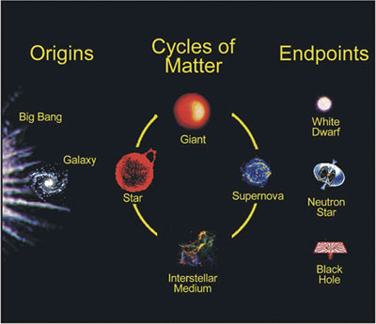
- Huge clouds of gas and dust form called
- From these nebulas, are born.
- Many stars to each other and form!

Light Year:

Stars:

Our SUN:

- Distance from Earth =

- Light given off by the sun takes to get to earth

Our Galaxy:

- Diameter of our galaxy:

- Thickness of our galaxy:

- Nearest Galaxy:

Name: Date:
Environmental Science Ms. Rinaldo

The Universe

Major Components in the Universe
- Galaxy –

  - Star –

- Types of Galaxies

1. Spiral -

2. elliptical –

3. Irregular –

- Constellations –

Stars:
- A star begins their lives in a

- Stars have a that is dependent on its
  - The more
    - mass stars (small stars=MOST stars) survive for of years
    - mass stars (large stars) survive for a few years

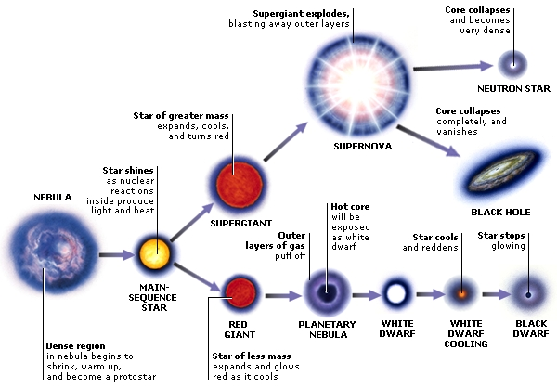

Solar System

Planets

Processes Impacting Planets

- Tectonics

- Volcanism

- Weathering and Erosion

- Impact Cratering

Planet Classifications

Terrestrial Planets

Gas Planets

Atmosphere

- Greenhouse Effect

